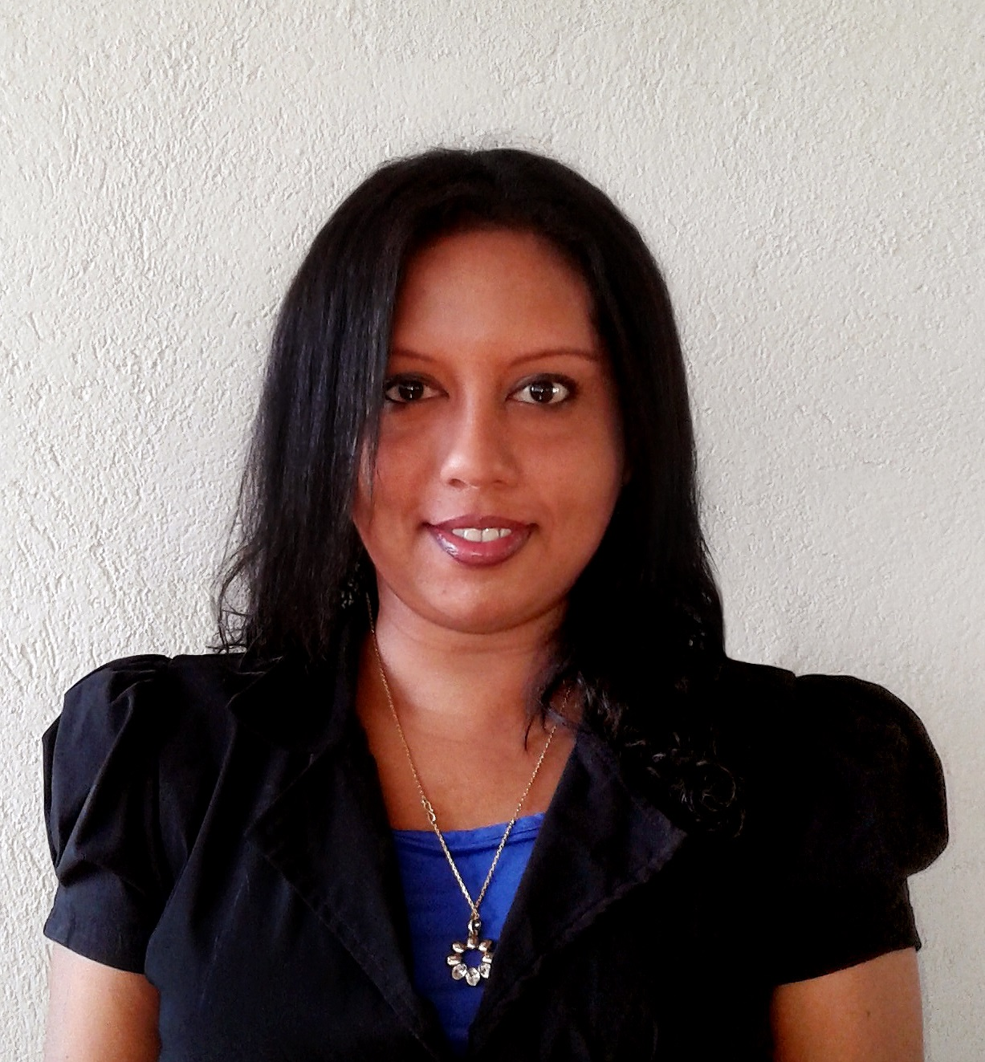

To secure a responsible as well as a challenging position in a progressive organization which would provide an opportunity for personal growth and career advancement. Further to contribute towards the growth of the organization with the skills & the competencies I have gained over 09 years in the fields of Business Development, HR and Administration.My Key strengths are Excellent Coordination skills, Ambitious and result oriented, Ability to work in a diverse and a dynamic environment, Innovate and ability to work under pressure, Likeability to accept any challenge, have undergone extensive Training & Development, Excellent Presentation & Communication Skills and People Management.

**Career Objectives**

**Address:**

No. 10/1, St. Mary’s Road,

Mount Lavinia.

**Email:**dul_sami@hotmail.com

**Mobile:**0716032392

**TRIDENT HOLDINGS PTE LTD –** Asst. Manager HR Administration  **Present**

I am currently working as a Asst. Manager HR & Administration for Trident Holdings Pte Ltd, from November 2013handling the HR and Administration work in the organization.

**Redington SL PTE LTD -** Senior Executive - Commercial & Administration  **October 2012 – December 2013**

Worked as a Senior Executive – Commercial for Redington SL Pte Ltd from April 2014 handling the Administration work, reporting to the Singapore office and the local office and report handling with the vendors namely HP, Apple and Samsung in Sri Lanka.

**The Ceylon Chamber of Commerce –** Management Executive  **June 2007 – September 2012**

Commenced work at the Tourism Cluster (Associations) Department where responsibilities included:

* Scheduling of meetings, attending meetings, preparation of minutes and following up on work arising from the minutes
* Organizing and coordinating events, seminars , training programmes and functions of the Associations
* Assisting the members of the Associations and attending to general correspondence
* Preparation of Annual reports, Newsletters, etc.
* Preparation of material for the websites of the Associations
* Coordinate/ attend meetings held with the Government Authorities such as Sri Lanka Tourism/ Civil Aviation Authority etc..
* Assisting and promoting Chamber services, events and seminars
* Coordinate Between High commissions/Embassies

Appointed as the Secretary of the IATA Agents Association of Sri Lanka – in August 2007, where I was given additional responsibilities, which included;

* Preparation of minutes and attending to follow up on pending matters
* Organizing events, seminars and functions for the Council
* Attending the Annual General Meetings abroad representing IATA Agents Association of Sri Lanka. Have visited Thailand, India, Malaysia, Italy, Dubai, China ,Singapore and UK
* Assisting the members of the Council and attending to general correspondence

Assisted the following Associations :- Sri Lanka Institute of Directors, Sri Lanka Association of Inbound Tour Operators, Shippers Council, Software Exporters Association of Sri Lanka.

**Work Experience**

**BMW Prestige International (Pvt) Ltd –** Confidential Secretary **June 2006 – May 2007**

* Developed excellent administrative skills and secretarial skills.
* Worked under pressure in a fast moving and often stressful environment.
* Developed excellent telephone and communication skills in a pressurised business.

**Jetwing Travels (Pvt) Ltd** - Outbound Tour Assistance **May 2005 – February 2006**

* Developed excellent customer care skills with the clients and the Overseas Agents
* Handled Air Tickets, Hotel Accommodation, Transport logistics and excursions of the clients
* Worked as a part of a team to achieve set business and sales targets.
* Dealt with customer complaints and enquires.
* Had to be flexible, worked shifts at short notice
* Successfully completed the Master of Business Administration (MBA) at ICBT University affiliated to Cardiff Metropolitan University (UWIC formally known as University of Wales) which commenced in December 2013. (Completed the following subjects :- Marketing, Organization Behavior, Accounting for Decision Makers, Strategic Management, International Business Management, Project management ,Research Methods ,The Thesis and the VIVA).
* Successfully completed Higher Diploma in Business Management at Australian College of Business and Technology (ACBT) in August 2010.
* Diploma in Airline Marketing, Ticketing & Reservations at International Airline Ticketing Academy
* Diploma in English at International College of Business & Technology (I.C.B.T)
* Diploma in Confidential Secretariat course at Politechnic (Pvt) Ltd
* Higher Diploma in Human Resources Management at IPM Sri Lanka
* Successfully completed a programme in report writing at Cosmopolitan Learning Academy (CLA)
* Successfully completed Music theory and practical exams obtaining Honours (stage 5) at Institute of Music and Speech. (I.M.S)
* Assisted the Education Services Department of the British Council Sri Lanka at the Education UK Exhibition 2007,2008 in Colombo.
* Proficient in Microsoft office, including Word, Excel, PowerPoint and Access
* Good standard of written and spoken English.

**Professional Qualifications**

**Educational Qualifications**

**Passed the G.C.E (O/L) Examination in – 2000**

**Subject** **Grade obtained**

Sinhala Language D

Social Studies D

English D

Mathematics D

Commerce & Accounts C

Buddhism C

English Literature C

Science S

**Passed the G.C.E. (A/L) Examination in – 2003**

General English A

Business Studies C

Accounting S

Economics S

* Proficient in English and Sinhalese
* High degree of ability to work in a computerized environment
* Experience in drafting annual reports
* Analytical and decision making skills
* Ability to work in a team-based work environment involving organizing, co-coordinating, negotiating, loyalty and commitment.
* Member of the English, Sinhala & Buddhist Union
* Member of the under 15 Net Ball Team
* Secretary of the English Literary Association 2001
* Member of the Commerce Society 2002
* Took part in Inter School choir Festivals

**Language and other Competencies**

**Extra-Curricular Activities**

**Name:** DularaEranthiSamarasinghe

**Address:** 10/1, St. Mary’s Road, Mount Lavinia.

**Date of Birth:** 2nd December, 1984

**Sex:** Female

**Nationality:** Sri Lankan

**Civil Status:** Single

**Schools attended:** Holy Family Convent, Bambalapitiya.

**Mr.VipulaWanigasekera**

Director General

General Manager – SLCB, Act Director General SLTDA

**SRI LANKA TOURISUM**

78, Galle Road

Colombo 03

Tel 2440002, 0714880574

Email :[vipulaslcb@sltnet.lk](mailto:vipulaslcb@sltnet.lk)

**Mr.Chandana De Silva**

Country Manager

**Emirates Airlines**

Hemas House

75, Braybrooke Place

Colombo 02

Tel: 0777 – 760700

E-mail: [chandana.desilva@emirates.com](mailto:chandana.desilva@emirates.com)

I would like to submit my curriculum vitae for your favourable consideration for the suitable placement at your esteemed organization. I can prove myself to be asset and work at the entire satisfactions of the management based on my background.

________________________________ ____________________________________

Date: **DularaSamarasinghe**

**Personal Details**

**Referees**